Pacific giant salamander

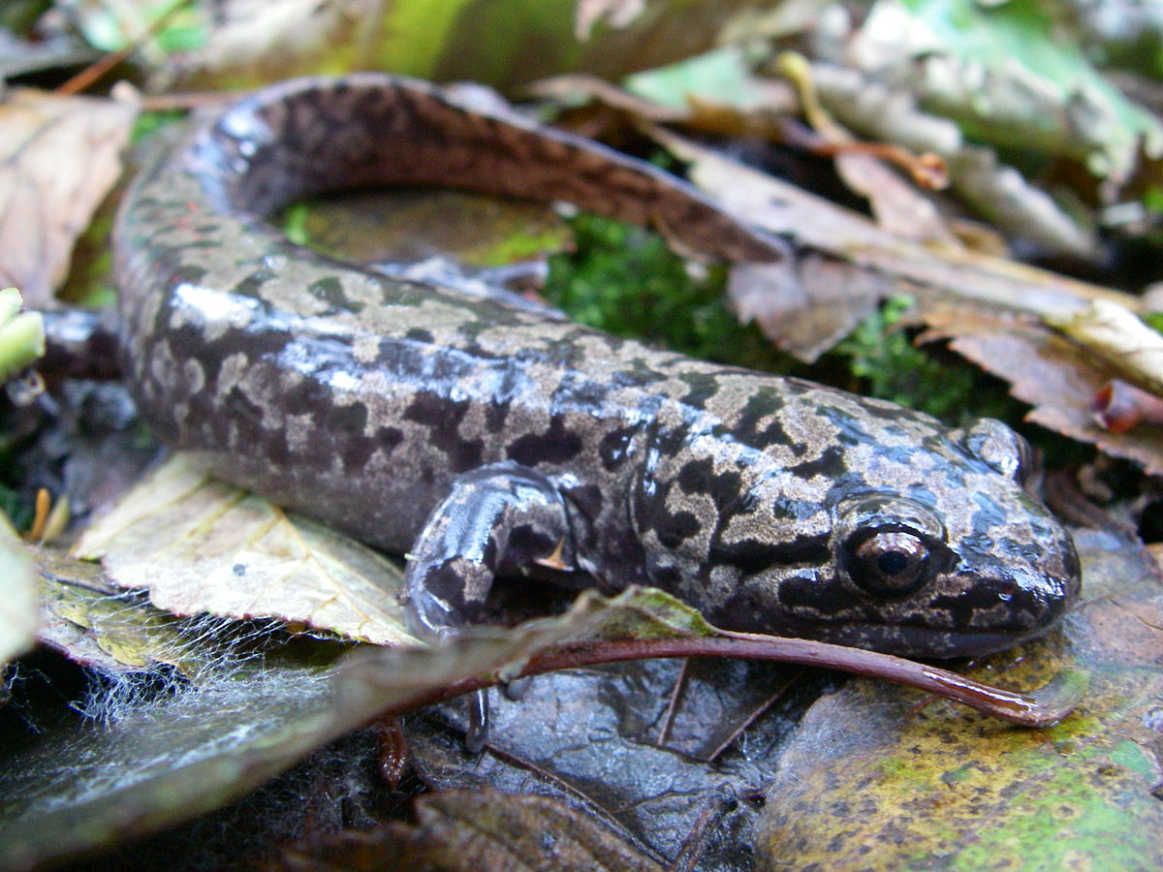

Specimens are up to 30 cm (12 in) long, and are found in the western United States and southwestern [British Columbia](https://en.wikipedia.org/wiki/British_Columbia). Except for their size, they are similar to the [mole salamander](https://en.wikipedia.org/wiki/Mole_salamander)family (Ambystomatidae), in which they were originally included.[[1]](https://en.wikipedia.org/wiki/Pacific_giant_salamander#cite_note-1)

While most salamanders are silent, the Pacific giant salamander is one of several salamanders that have [vocal](https://en.wikipedia.org/wiki/Vocal) abilities. When startled, these salamanders may respond with a croaky-sounding cry similar to that of a barking dog. Members of this family can either be terrestrial or aquatic as adults.

Taxonomy[[edit](https://en.wikipedia.org/w/index.php?title=Pacific_giant_salamander&action=edit&section=2)]

The family includes only a [single genus](https://en.wikipedia.org/wiki/Monotypic), *Dicamptodon*. The [genus](https://en.wikipedia.org/wiki/Genus) was formerly thought to contain two species, [Cope's giant salamander](https://en.wikipedia.org/wiki/Cope%27s_giant_salamander) (*D. copei*) on the [Olympic Peninsula](https://en.wikipedia.org/wiki/Olympic_Peninsula), [Washington](https://en.wikipedia.org/wiki/Washington_(state)), and the Pacific giant salamander (*D. ensatus*) which consisted of three geographic populations, an [Idaho](https://en.wikipedia.org/wiki/Idaho) isolate, a group in northern [California](https://en.wikipedia.org/wiki/California), and a group in [Oregon](https://en.wikipedia.org/wiki/Oregon) and Washington.[[2]](https://en.wikipedia.org/wiki/Pacific_giant_salamander#cite_note-2) In 1989, genetic studies showed *D. copei* to be a distinct species, and the *D. ensatus* populations to consist of three species: the [Idaho giant salamander](https://en.wikipedia.org/wiki/Idaho_giant_salamander) (*D. aterrimus*) in Idaho, and two highly divergent species with a narrow hybrid zone in California, the [coastal giant salamander](https://en.wikipedia.org/wiki/Coastal_giant_salamander) (*D. tenebrosus*) (ranging from northern California to Washington), and the [California giant salamander](https://en.wikipedia.org/wiki/California_giant_salamander) (*D. ensatus*) (limited only from [Santa Cruz County](https://en.wikipedia.org/wiki/Santa_Cruz_County,_California) to [Mendocino County](https://en.wikipedia.org/wiki/Mendocino_County) in California).[[3]](https://en.wikipedia.org/wiki/Pacific_giant_salamander#cite_note-3)